piyush kumar

A1: Simulation: Data-Driven Strategic Recommendations and Business Report

May 4, 2023

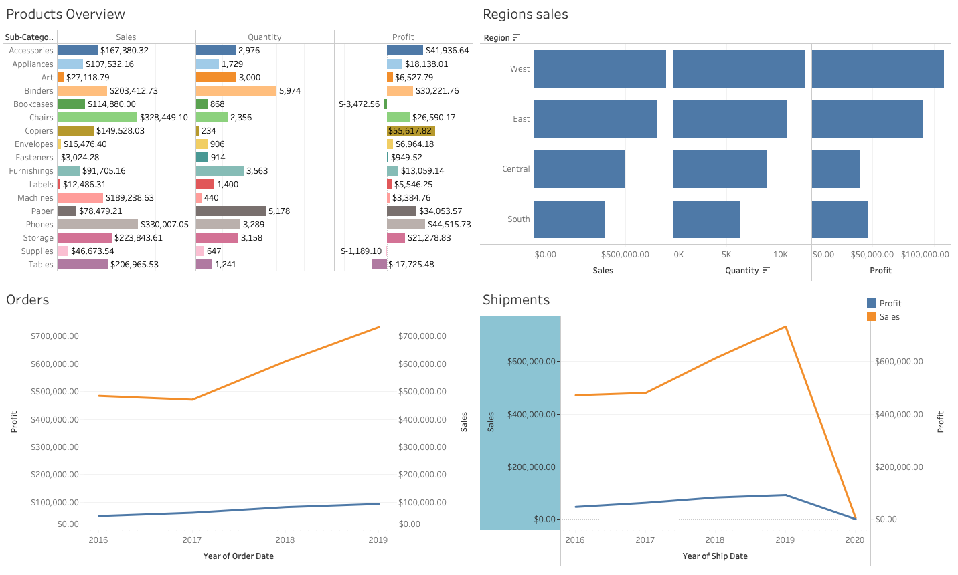

**Report for management with findings & Business insights:**

I have directed an examination of the sales and profits of Hult superstore information throughout the course of recent years, and I have a few discoveries and bits of knowledge to impart to you.

It, right off the bat, is obvious that the deals are most noteworthy in the West district, trailed by East, Focal and South. Likewise, the benefits are additionally most elevated in the West locale, trailed by East, Focal and South.

Nonetheless, while there has been a huge expansion in deals on a year-on-year premise, the benefits have not expanded significantly. This shows that there is a need to diminish the expense of items to further develop productivity. I suggest leading an exhaustive examination of expense structure and investigating ways of diminishing expenses without settling on quality.

Moreover, it is significant that the quantity of shipments has declined radically in 2020 contrasted with the earlier years. This could be because of the effect of the Coronavirus pandemic, which has upset worldwide stock chains and impacted shopper conduct. It is critical to screen what is happening intently and adjust procedures appropriately to relieve any adverse consequences on business.

As far as item classes, telephones and seats are the most elevated selling things in the sub-classifications, demonstrating that there are serious areas of strength for a for these items. Then again, cabinets, supplies, and tables are not productive sub-classes, and it very well might merit rethinking interest around there.

One expected an open door for development and benefit is in the copiers and extras class, where there is an opportunity to create a lot of gain. I suggest investigating this classification further and distinguishing ways of growing your contributions around here.

At last, it is quite significant that the clasp classification had immaterial deals, which may not merit chasing after further. It is fundamental to assess the exhibition of every item classification consistently and pursue vital choices in view of the information.

**Recommendations:**

In view of the assessment discoveries, it is suggested that Hult superstore ought to zero in on growing its presence in the West locale, which has demonstrated to be the most productive market. The business needs to look into ways to cut costs without sacrificing quality if it wants to see improvements in profitability.

The effect of the Coronavirus pandemic on worldwide stock chains and buyer conduct ought to likewise be firmly observed to appropriately adjust business procedures. Hult Superstore should look into growth opportunities in the copiers and accessories category while reconsidering investments in unprofitable sub-categories like cabinets, supplies, and tables in terms of product categories.

It is essential to regularly evaluate the performance of each product category in order to identify potential growth and profitability opportunities. In the long run, Hult Superstore can boost sales and profits by implementing these suggestions.